Teacher Preparation Notes for
Alcoholic Fermentation in Yeast – A Bioengineering Design Challenge

This multi-part minds-on, hands-on activity helps students to understand both alcoholic fermentation and the engineering design process. Students begin by learning about alcoholic fermentation in yeast. To test whether grains of yeast can carry out alcoholic fermentation, students compare CO₂ production by grains of yeast in sugar water vs. two controls. Then, students are introduced to the bioengineering design challenge to find the optimum temperature and sucrose concentration to maximize rapid CO₂ production. Students are guided through the basic engineering steps of applying the relevant scientific background to the design challenge, planning for systematic testing of possible design solutions, drawing tentative conclusions from the results of this testing, clarifying the criteria for an optimum design solution, and planning for further testing.

You may want to complete the questions on pages 1-2 of the Student Handout on the day before the lab period for the initial experiment. This should ensure that your students will have enough time to complete the experiment and interpretation of results (pages 3-4 of the Student Handout) during a 50-minute lab period. The Bioengineering Design Challenge will probably require 2-3 50-minute class periods. This is in line with previous research which indicates that significant class time is required for students to develop a meaningful understanding of the engineering design process.

Before photocopying the Student Handout, you will need to make two decisions.
- If you are not planning to include the design challenge, we recommend the shorter simpler Student Handout.
- If you have 27 or more students per class (so you have 9-10 student groups per class), you will want to use the version of pages 7-9 of the Student Handout provided in the Appendix at the end of these Teacher Preparation Notes.

If your students are not familiar with ATP, we recommend that you precede this alcoholic fermentation activity with our analysis and discussion activity, "How do organisms use energy?" (https://serendipstudio.org/exchange/bioactivities/energy).

Table of Contents
Learning Goals – page 2
Equipment and Supplies – pages 2-3
Instructional Suggestions and Background Information
General – page 4
I. Introduction – pages 4-7
II. Do the grains of yeast contain living cells that can carry out alcoholic fermentation? – pages 8-9
III. Bioengineering Design Challenge – pages 9-13
Related Activities – page 13
Appendix –Substitute pages 7-9 in the Student Handout for large classes – pages 14-16

Learning Goals
In accord with the Next Generation Science Standards, this activity:
- engages students in recommended Scientific and Engineering Practices, including:
- “Constructing Explanations and Designing Solutions. Apply scientific ideas, principles, and/or evidence to provide an explanation of phenomena and solve design problems, taking into account possible unanticipated effects.”
- “Planning and Carrying out Investigations. Make directional hypotheses that specify what happens to a dependent variable when an independent variable is manipulated. Manipulate variables and collect data about a complex model of a proposed process or system to identify failure points or improved performance relative to criteria for success or other variables.”
- “Analyzing and Interpreting Data: Analyze data to identify design features or characteristics of the components of a proposed process or system to optimize it relative to criteria for success.”
- helps students to understand the Crosscutting Concept, "Cause and Effect: Mechanism and Prediction. Changes in systems may have various causes that may not have equal effects."
- can help students to prepare for Performance Expectation HS-LS2-3, "Construct and revise an explanation based on evidence for the cycling of matter and flow of energy in aerobic and anaerobic conditions."
- helps students to learn the Disciplinary Core Ideas:
- LS1.A, "proteins… carry out most of the work of cells" (with regard to protein enzymes)
- LS2.B, "Photosynthesis and cellular respiration (including anaerobic processes) provide most of the energy for life processes."

Additional Content Learning Goals
- In alcoholic fermentation, a cell metabolizes glucose to provide the energy to produce ATP. Alcoholic fermentation also produces ethanol and CO₂.
- The chemical reactions in alcoholic fermentation are catalyzed by enzymes. As is typical of enzyme reactions, these reactions can be speeded up by increasing the concentration of substrate and/or increasing temperature to an optimum level; both of these changes increase the rate at which substrate molecules collide with the active sites of the enzymes. Increases in temperature above the optimum result in changes in the shape of the active site, which slows the rate of reaction.
- To meet an engineering design challenge, you should have clear criteria for the design solution and use relevant scientific information to plan systematic tests of possible design solutions.

Equipment and Supplies – II. Testing for Alcoholic Fermentation in Yeast Cells
Equipment (number needed for each group of three students in your largest class)
- 1 graduated cylinder to measure 80 mL
- 1-3 rulers to measure millimeters
- 1 timer or some other way of keeping track of minutes
- Scale, accurate to 0.1 g (If you don’t have enough scales for each group (or two groups), you will probably want to use measuring spoons instead.)
- 1 thermometer for the range of 20-60°C (There should be some way to prop this in the warm water bath for the duration of the experiment (or you could use a rapid response cooking thermometer).)
- 1 container that can be used as a warm water bath for the cups (or heated warm-water bath if you have them available)
- 1 marker or other method for labeling cups
Supplies (amount needed for each group of three students)
- 3 10-oz. clear plastic cups (or another clear, relatively narrow and tall container of similar size with thin walls that readily conduct heat)
- 6 plastic spoons for stirring
- 12 g of yeast plus some grains of yeast for students to examine to answer question 4 (We recommend fast-rising highly active baker’s yeast or bread maker yeast. You should check that your yeast is active before you begin this activity with your students; use the instructions for cup 1 (on page 3 of the Student Handout) to prepare a cup, and look for a layer of bubbles (foam) on top. There are 21 grams of yeast in each triple package of yeast.)
- 1.0 g of sucrose
- Warm water (~35°C. The water needs to be warm to ensure that the yeast metabolism will be rapid enough to produce good results in the 10-minute observation period. If your students are mixing hot and cold water, you may want to pass around one or two cups of 35° water, so your students will have some idea of what proportions of hot and cold water to mix.)
Preparation
- You may want to use the instructions on page 3 of the Student Handout to prepare one or two cups of living yeast in sugar water before or during the class where you discuss pages 1-2 of the Student Handout. At the end of the discussion of page 2, you may want to pass these cups around so students can see what the layer of foam produced by the CO₂ bubbles looks like.
- Each student group will use 8 g of live yeast + 80 mL of suspension of dead yeast cells. For the suspension, use the proportions of 4 g of yeast in 80 mL of water; boil for 5 minutes to kill the yeast cells; before distributing 80 mL to each student group, adjust temperature to ~35°C and be sure to stir the suspension thoroughly.

Equipment and Supplies – III. Bioengineering Design Challenge
You will need the same equipment and supplies as for part II, including:
- an additional 12 g of live yeast per student group (no dead yeast needed);
- a quantity of sucrose that will vary, depending on students’ proposed testing recommendations (questions 14-15) and the resulting Class Investigation Plan (see page 11 of these Teacher Preparation Notes);
- access to hot and cold water in order to vary the temperature of the water in the cups and bath.

Instructional Suggestions and Background Information
In the Student Handout, numbers in bold indicate questions for the students to answer and letters in bold indicate steps in the experimental procedure for the students to do.

You can use the Word document to make revisions. If you use the Word version of the Student Handout, please check the PDF of the Student Handout, which shows the correct format.

A key is available upon request to Ingrid Waldron (iwaldron@upenn.edu). The following paragraphs provide instructional suggestions and background information, some for inclusion in your class discussions and some for your understanding and/or responding to student questions.

I. Introduction
Question 1 recommends the first minute and 25 seconds of the 6-minute video “Yeast – a tiny but powerful story” (https://www.youtube.com/watch?v=5UyaZbNkjP0). You may want to substitute the 5-minute video “Why does bread have holes in it?” (https://www.youtube.com/watch?v=JlDlzr7Ljrw), which is aimed at a younger audience and is easier to understand. Question 1 is intended to explore what the students already know. You are encouraged to welcome all student answers and leave this question open for further exploration.

Yeast are single cell fungi which absorb nutrients from their environment (e.g. bread dough, grapes, tree bark). The yeast which is used to make bread is Saccharomyces cerevisiae. These yeast carry out alcoholic fermentation as the dough rises and during the early part of bread baking; bubbles of CO₂ are trapped by the elastic dough (https://www.thespruceeats.com/main-types-of-leavening-agents-and-how-they-work-4125705). As the bread bakes, the ethanol produced by alcoholic fermentation evaporates. S. cerevisiae and other members of the same genus are used to make wine and beer where, obviously, the production of alcohol is the major goal.

Yeast is often sold as packets of little dry grains of yeast cells. It is estimated that each grain of dry yeast has hundreds of thousands of yeast cells and there are more than 50 billion yeast cells in 1 g of dry yeast.

As discussed in the Student Handout, one way to test whether these little dry grains of yeast contain cells that are alive is to test whether they can carry out alcoholic fermentation. In
alcoholic fermentation a cell produces ATP using energy from reactions that require glucose, but do not require oxygen. If your students would benefit from a review of ATP, you can show them this figure and ask questions such as:  - What is the difference between ATP and ADP?  - Where does the “energy in” come from?  - Where does the “energy out” go? | 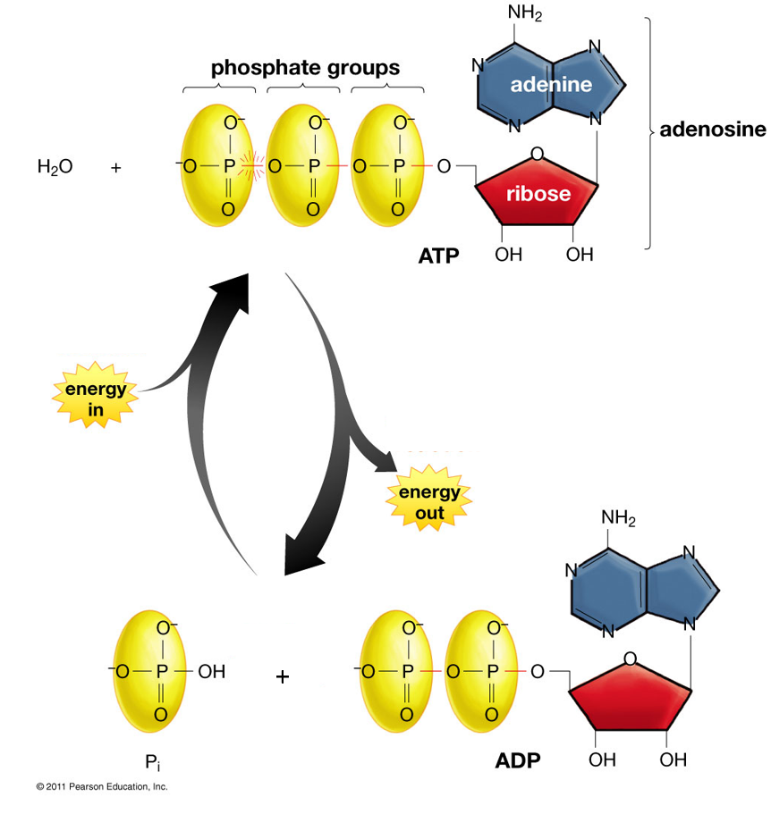  (Figure from Krogh, Biology – A Guide to the Natural World, Fifth Edition)

Yeast can convert sucrose to two molecules of glucose. | 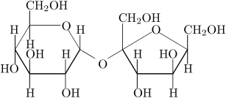  Sucrose | 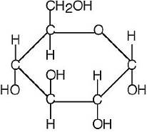  Glucose

Alcoholic fermentation is the primary process used by Saccharomyces cerevisiae to produce ATP. This figure shows additional information about the process of alcoholic fermentation (also called alcohol fermentation). The last step in alcoholic fermentation restores NADH to its original form, which is needed so fermentation can continue. | 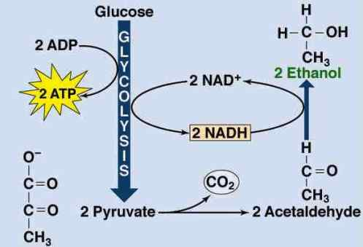  (https://www.accessscience.com/content/article/a253100)

You may want to contrast alcoholic fermentation with aerobic respiration (also called cellular respiration) which uses oxygen as an electron acceptor. Both fermentation and aerobic respiration begin with glycolysis, but aerobic respiration includes the citric acid cycle and electron transport chain, so much more ATP is produced per glucose molecule.
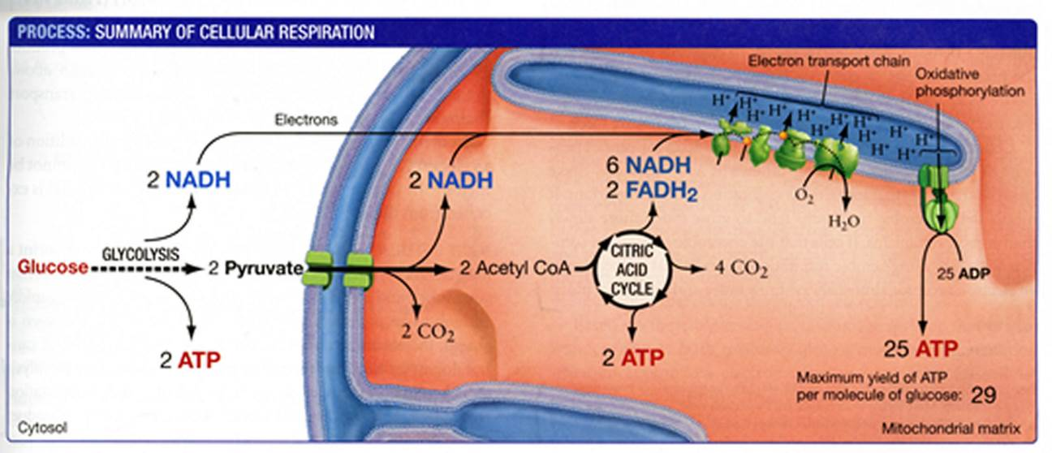(From "Biological Science" by Scott Freeman, Benjamin Cummings, 2011)

Since anaerobic fermentation results in the production of much less ATP per glucose molecule than aerobic respiration, it may seem puzzling that Saccharomyces cerevisiae often use anaerobic fermentation even when oxygen is available. However, the production of ethanol which spills over into the environment appears to give S. cerevisiae a competitive advantage, since S. cerevisiae is more tolerant of ethanol than many other microorganisms. Also,
S. cerevisiae is able to adopt a make-accumulate-consume-ethanol strategy in which S. cerevisiae use alcoholic fermentation to rapidly metabolize glucose and produce ethanol during an initial population growth phase and then switch to metabolizing ethanol when the glucose supply has been depleted. The oxidation of ethanol can supply energy for the production of additional ATP.  This figure shows evidence for the make-accumulate-consume-ethanol strategy in a laboratory setting. The same phenomenon appears to occur in fruits in nature. | 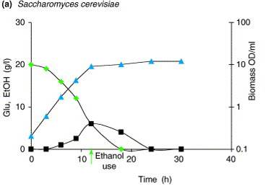  (squares = ethanol; triangles = biomass of  Saccharomyces cerevisiae; diamonds = glucose;  Piskur et al., 2006, Trends in Genetics)

As you discuss question 2c, you may want to show your students:
- the first 2.2 minutes of the video “Yeast Fermentation under the Microscope” (https://www.youtube.com/watch?v=7SQWnWwZM1E) or
- minutes 2-5.4 of “How Does Yeast Make Bread?” (https://www.youtube.com/watch?v=bS8TpHCK2cU), which shows the formation of bubbles of carbon dioxide produced by the yeast, and also explains more of the biology of yeast.

Question 3 is designed for students who already have a basic understanding of enzymes. If your students are not familiar with enzymes, you may want to:
- introduce basic concepts during class discussion of questions 3 and 13-14
- show your students the Amoeba Sisters 5.5-minute video, “Enzyme” (https://www.youtube.com/watch?v=qgVFkRn8f10)
- precede this alcoholic fermentation activity with an introduction to enzymes (e.g. the activity, "Enzymes Help Us Digest Food", https://serendipstudio.org/sci_edu/waldron/#enzymes)

This figure illustrates the concept of activation energy. It can be used to reinforce student understanding that enzymes speed up reactions by reducing the activation energy required. As a result of the reduced activation energy, many more of the substrate molecules have enough kinetic energy to provide the activation energy needed to reach the transition state. | 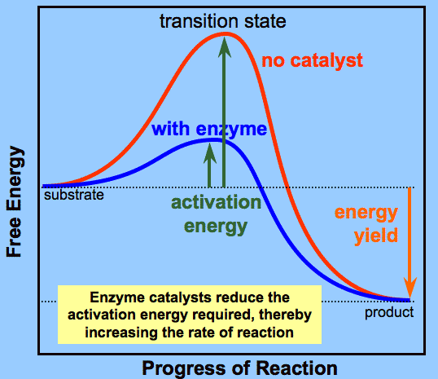  (http://plantphys.info/plant_physiology/images/enzenergy.gif )

The figure below shows the enzymes that are needed for the last two steps in alcoholic fermentation. Notice how the product of the first reaction shown is the substrate for the next reaction. Ten additional enzymes are needed for the earlier steps in alcoholic fermentation (collectively called glycolysis).
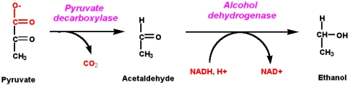
(http://chemwiki.ucdavis.edu/@api/deki/files/19458/ferm_01.jpg?size=bestfit&width=482&height=119&revision=1 )

For question 4, you will need to have some dry grains of yeast for your students to examine. In discussing student answers to question 4, please do not attempt to resolve any disagreements, but rather let the students discover the answers through the experiment in part II.

II. Do the grains of yeast contain living cells that can carry out alcoholic fermentation?
Question 5a refers to the cells in a dry grain of yeast as “dormant”. Under starvation conditions, yeast cells reduce metabolic activity drastically, which conserves resources and allows prolonged survival until food is available again. Students may find it helpful to think of dormancy as comparable to hibernation.

If your students are not familiar with the effects of adding baking soda to vinegar, you may want to include a classroom demonstration of this reaction before question 6.
NaHCO₃ + HC₂H₃O₂ – > NaC₂H₃O₂ + H₂CO₃ – > NaC₂H₃O₂ + H₂O + CO₂
This demonstration may help your students understand why we cannot assume that bubbles produced by yeast in sugar water are produced by alcoholic fermentation. It should be acknowledged that we are still making assumptions in interpreting the results (e.g., that the bubbles produced are CO₂).

In discussing question 7, you may want to relate the failure of dead yeast to produce CO₂ to the failure of bread to rise if an inexperienced baker prepares bread dough with very hot water (which can kill the yeast cells).

The detailed instructions for the experimental procedure (on page 3 of both versions of the Student Handout) will be useful for students as they move into part III, the Bioengineering Design Challenge, which requires careful control of variables and quantitative assessment of the amount of CO₂ produced. To ensure that your students follow these rather detailed procedures, you may want to have your students check off each step of the procedure as they complete it. Additional advice includes the following points.
- If students put too much water in the warm water bath (above the level of the liquid in the cups), this can cause the cups to tip over.
- Your students should be sure to distinguish between the layer of foam and a coating of yeast suspension on the side of the cup.
- If the foam layer in a cup is not even, your students can measure the depth at the thinnest and thickest points and calculate the average.

During the experiment, your students may notice a few bubbles on the surface of the cup with yeast in plain water; these are the aftereffects of stirring and not due to alcoholic fermentation, as indicated by the fact that the bubbles are present immediately after stirring and the amount of these bubbles does not increase over time. Careful observation of the cup with yeast in sugar water during the first few minutes reveals bubbles rising to the surface; these bubbles are coated with yeast suspension and generally do not pop, so this looks like bubbling lava.

We suggest that you post the table below for student groups to report the results of their experiments (as instructed on page 3 in each Student Handout). This table will provide the information students need to answer questions 11-12.

Group ID
Depth of foam layer (mm):
Possibly living yeast in sugar water (1)
Possibly living yeast in plain water (2)
Definitely dead yeast in sugar water (3)
Beginning temperature (°C)
Ending temperature (°C)

In question 12c, “reliable” refers to results that are consistent, and “valid” refers to results that accurately reflect the real world. Class discussion of student answers to question 12 can help your students to develop better experimental procedure, which will be important for success in the Bioengineering Design Challenge of Part III.

III. Bioengineering Design Challenge
Engineering design is not the same as trial-and-error "gadgeteering". The questions on pages 5-9 of the Student Handout (together with class discussions of student answers to these questions) provide the scaffolding to guide your students through the steps of a relatively rigorous engineering design process. This extended approach is in accord with previous research that indicates that significant class time is required for students to develop a meaningful understanding of the engineering process.

This Bioengineering Design Challenge includes several key features of engineering design, including:
- trade-offs between different goals in the Design Challenge and the need for clear, precise criteria for the design solution (question 27 and the preceding prose and figure)
- the need to consider scientific principles and previous research results in planning the testing to find a Design Solution (questions 13-16)
- the need to systematically test proposed Design Solutions (question 17).

Scientific Background (page 5 of the Student Handout)
Questions 13-14 are designed for students who understand the effects of temperature and substrate concentration on enzyme-catalyzed reactions. You may want to have your students mimic the activity of professional engineers who research the scientific literature for relevant information to assist their design process. Resources that may be helpful include:
- the discussion of enzymes that is available at https://ib.bioninja.com.au/standard-level/topic-2-molecular-biology/25-enzymes/enzyme-activity.html and/or https://www.khanacademy.org/science/ap-biology/cellular-energetics/environmental-impacts-on-enzyme-function/a/hs-enzymes-review; these sources can be useful for students who may have a basic understanding of enzymes but are having difficulty answering questions 13-14;
- the information below (with the first figure on page 7 of these Teacher Preparation Notes).

The rate of reaction reaches a maximum at an optimum temperature for each enzyme. Initially, as temperature increases, the rate of reaction increases due to:
- the increased rate of motion of the substrate molecules, which results in more collisions of substrate molecules with the active sites of enzyme molecules and more of the substrate molecules having sufficient kinetic energy to provide the needed activation energy;
- the greater flexibility of the enzyme molecules, which facilitates induced fit.
As temperature increases above the optimum level, the increase in vibrational energy of the atoms in the enzyme molecules puts strain on the bonds that are responsible for the secondary and tertiary structure of the enzyme molecules, so the active site changes shape and is less able to catalyze the reaction. With sufficient increases in temperature, the enzyme becomes denatured and no longer functions as a catalyst.

When the concentration of substrate increases, this increases the rate at which substrate molecules collide with the active sites of enzyme molecules and thus increases the rate of reaction. Once the concentration of substrate is high enough to saturate the active sites of the enzyme molecules, the reaction rate reaches a maximum and the curve of rate of reaction vs. substrate concentration plateaus. High sucrose levels can result in osmotic stress for yeast cells, which can result in decreased CO₂ production.

Finding a Design Solution (pages 6-9 in the Student Handout)
The overall sequence of this section is as follows:
- Students propose ranges of temperatures and sucrose amounts to test, and they evaluate two different approaches to testing (questions 15-17).
- You lead a class discussion and develop a Class Investigation Plan to evaluate possible Design Solutions.
- Students carry out the experiments (using the procedure shown on the bottom of page 6 of the Student Handout).
- You compile the data from question 18 for all the student groups and display the compiled data in the table from question 19.
- Students analyze these data to evaluate the effects of different temperatures and different amounts of sucrose (questions 20- 27). Students propose a Design Solution based on these experimental results and suggest further testing to improve the Design Solution (question 28).
Obviously, you will also guide the experimentation and graphing activities and lead class discussions of the questions in this section. The following paragraphs offer specific advice and information.

Student proposals for the range of temperatures and sucrose amounts to be tested (questions 15-16) should be based on:
- student experience in Part II,
- the criteria for a good design solution (underlined in the second paragraph on page 5 of the Student Handout),
- the scientific background (questions 13-14).
Therefore, you will probably want to have a class discussion of student answers to questions 13-14 before your students answer questions 15-16.

For question 17a, a possible advantage of strategy A is the possibility that a student group may happen to test an optimum combination of temperature and sucrose concentration. Class discussion of student answers to question 17b will provide the opportunity to discuss the importance of replicating tests and of evaluating the effects of each independent variable separately by testing different levels of each independent variable while holding the other independent variable constant. Many students will be inclined to change both independent variables simultaneously which makes it impossible to identify the specific variable responsible for any observed effects. The advantages of strategy B are so great that you should adopt this strategy.

If you have 27 or more students per class (so you have 9-10 student groups per class), you should use the version of pages 7-9 of the Student Handout provided in the Appendix at the end of these Teacher Preparation Notes.

Class discussion of student answers to questions 15-17 should provide the basis for developing a Class Investigation Plan for testing possible design solutions. As you discuss the Class Investigation Plan, you will probably want students to view the table in question 19. This will help students to visualize that collectively they will test the amount of CO₂ production for three different sucrose amounts at each of four different temperatures (or five if you have 9-10 student groups). You will also need this table to display the results of the Class Investigation, which students will use to answer questions 20-28.

As you develop your Class Investigation Plan, you will have to make choices based on:
- the range of sucrose amounts and temperatures your students want to assess;
- the desirability of including the temperature and amount of sucrose used in part II, since you know that yeast will produce CO₂ under these conditions;
- the desirability of having replication for greater reliability of results;
- the number of student groups in your class.

As you decide on the values for the independent variables, you can write the sucrose amounts in the first column of the table in question 19 and the assigned temperatures in the top row. For practical reasons, we recommend that each student group test three different sucrose amounts at a single temperature, and different student groups will test at different temperatures. These tests will allow your class to evaluate the effects of sucrose concentration, the effects of temperature, and whether the effects of each independent variable are consistent at different levels of the other independent variable.

You may want to know the results of previous research, but you should not reveal these results to students in order to preserve their interest during this Design Challenge. Optimum temperatures for yeast activity are often estimated as in the 30-35°C range. High sucrose levels (>~10%, which would be 8.0 g of sucrose in 80 g of water) can result in decreased CO₂ production, due to osmotic stress on the yeast cells. The effects of each independent variable appear to be consistent at different levels of the other independent variable.

Students will need to be as careful as possible to follow exactly the procedure described on page 6 of the Student Handout in order to get relatively reliable and valid results. It is important that all of the conditions except for the amount of sucrose be the same for different cups in the same student group; for example, the water bath equalizes the temperature in the three cups for each student group. Even with careful experimental technique, results may be inconsistent, and it probably won’t be possible to identify exactly the optimum temperature or amount of sucrose. However, the results should be sufficiently accurate for students to see general trends.

For ease of comparison, students should use the same scales for all the graphs in questions 20 and 24a. If any of the values in the table in question 19 is so high that inclusion would distort the range on the vertical axes, you may want to have a discussion with the group that produced these high values and a class discussion of the pros and cons of eliminating aberrant data from your analysis.

The graphs in questions 20 and 24a will be helpful for the following reasons:
- These graphs can help students to evaluate the relationship between the rate of CO₂ production and different levels of the independent variables (questions 21 and 25). This
will help students to identify optimum Design Solutions (questions 24b and 28a)
- These graphs may show variation in different replicates of the same conditions which will help students understand the importance of replication before drawing firm conclusions. In a class discussion of question 23, you could ask students if they are aware of any differences in technique that could have caused any results that deviate from general trends; this can help students recognize the importance of precision in experimental technique to achieve accurate results.

Question 27, with the preceding paragraph and figure, provides the opportunity to discuss how design solutions often involve trade-offs between different desirable characteristics. Choosing point A on the graph as the criterion for sucrose concentration will maximize CO₂ production. Choosing point B will prevent the bread from being too sweet with almost as much CO₂ production as choosing point A. You may want to mention the general principle in engineering design that there may be multiple possible satisfactory design solutions.

Student answers to question 28a should obviously be based on their findings in questions 20-26. Students should use the results of their analyses in questions 20-28a to think about how to answer question 28b. To get the data that they would need to improve their Design Solution, they might need to:
- extend the range of their investigations for either or both of the independent variables (temperature and amount of sucrose)
- get more detailed data within the range they have already investigated for either or both of the independent variables
- replicate results that were inconclusive due to inconsistent findings.
In the discussion of this question, you may want to point out that the need for repeated rounds of testing and experiments is typical of engineering design and scientific investigation generally. The results of each round of experiments provide the basis for planning the next round of experiments.

For question 28c, your students should consider how the yeast and sucrose may interact differently in bread dough vs. an experimental cup (see e.g. discussion of interactions of various bread ingredients with gluten at https://www.thespruceeats.com/yeast-bread-ingredients-478798). Also, testing with bread dough will allow evaluation of taste and texture. In contrast, testing in cups is faster and cheaper.

If you have the class time, we recommend that you follow up question 28b by having your students do further testing with the goal of improving their Design Solution. This will help your students to understand the iterative nature of the engineering design process.

Related Activities
- "How do muscles get the energy they need for athletic activity?" (https://serendipstudio.org/exchange/bioactivities/energyathlete) is an analysis and discussion activity in which students learn how aerobic cellular respiration, anaerobic fermentation, and creatine phosphate contribute to ATP production in muscle cells during different types of athletic activity. Students also learn how multiple body systems work together to supply glucose and oxygen for aerobic cellular respiration.
- "Using Yeast to Understand Cellular Processes" (https://www.carolina.com/teacher-resources/Interactive/using-yeast-to-understand-cellular-processes/tr10888.tr?question=cell%20transport%20with%20Baker%27s%20yeast) includes experiments with boiled and unboiled yeast in which students observe molecular transport, reproduction and metabolism.
- Chapter 10 of Gourmet Lab – the Scientific Principles behind Your Favorite Foods (go to https://www.nsta.org/ and search by title or https://www.amazon.com/Gourmet-Lab-Scientific-Principles-Favorite/dp/1936137089) presents an investigation of the effects of changes in ingredients on the volume and density of cinnamon rolls.

Appendix –Substitute pages 7-9 in the Student Handout for large classes
19. Your teacher will provide the information to fill out as many of the columns as possible in this table. (Each column will give the data from one student group.)

Amount of sucrose (grams in 80 mL of water) | Depth of Foam Layer (mm)
 | Assigned Temperature 1 (______°C) |  | Assigned Temperature 2 (______°C) |  | Assigned Temperature 3 (______°C) |  | Assigned Temperature 4 (______°C) |  | Assigned Temperature 5 (______°C)
 | Test 1 | Test 2 | Test 1 | Test 2 | Test 1 | Test 2 | Test 1 | Test 2 | Test 1 | Test 2
Lowest amount (_______ g)
Medium amount (_______ g)
Highest amount (_______ g)
Beginning temperature
Ending temperature

20. Graph the depth of the foam layer vs. beginning temperature for each amount of sucrose. Choose a range for each variable that will include all the data points. Label the axes, which should be the same in all three graphs. Use a dot to indicate each Test 1 result and a small x to indicate each Test 2 result.
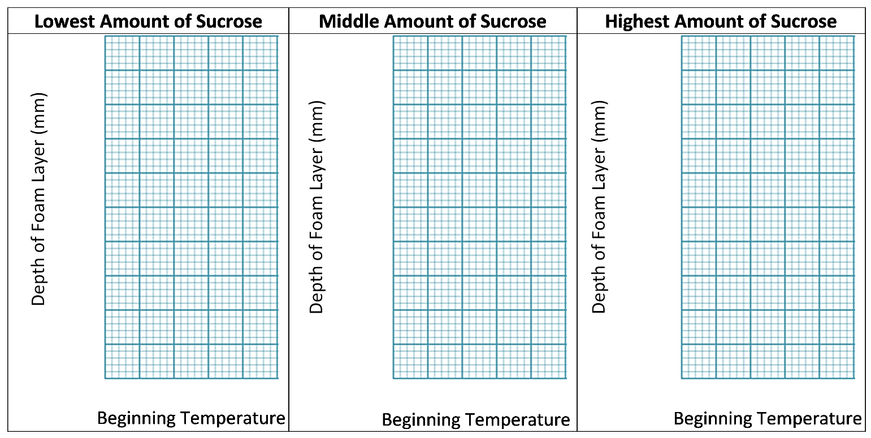
21. Interpret the results shown in the above graphs. What effects did different temperatures have on the amount of CO₂ produced?

22a. This graph shows the expected relationship between temperature and rate of bubble production. Circle the part of the graph that most closely resembles your graphs in question 20. If you are not sure which part of the graph to circle, explain your uncertainty. | 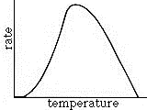

22b. What additional tests would you recommend to find the optimum temperature for maximum CO₂ production? Explain your reasoning.

23a. Compare the effects of temperature for tests 1 and 2 in each graph in question 20. Were the effects of temperature consistent for these replicate tests?

23b. If the effects of temperature were not consistent, what could account for any differences?

23c. Were the effects of temperature consistent for different amounts of sucrose? If not, what could account for the variation?

24a. Graph the depth of the foam layer vs. the amount of sucrose per 80 mL of water for each temperature. Choose a range for each variable that will include all the data points. Label the axes, which should be the same in all five graphs. Use a dot to indicate each Test 1 result and a small x to indicate each Test 2 result.  24b. Circle the two highest depth-of-foam-layer results and note here the amount of sucrose and the temperature for maximum CO₂ production. | 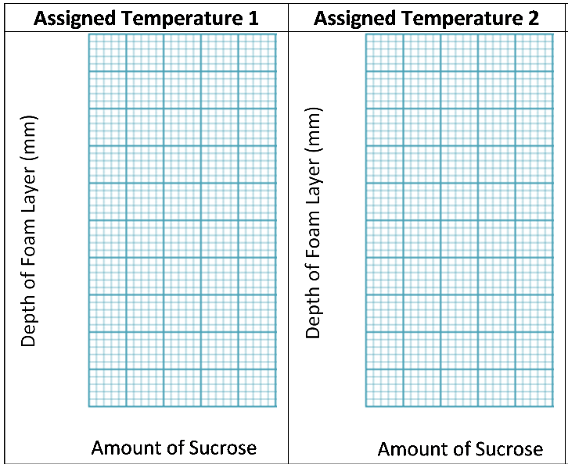
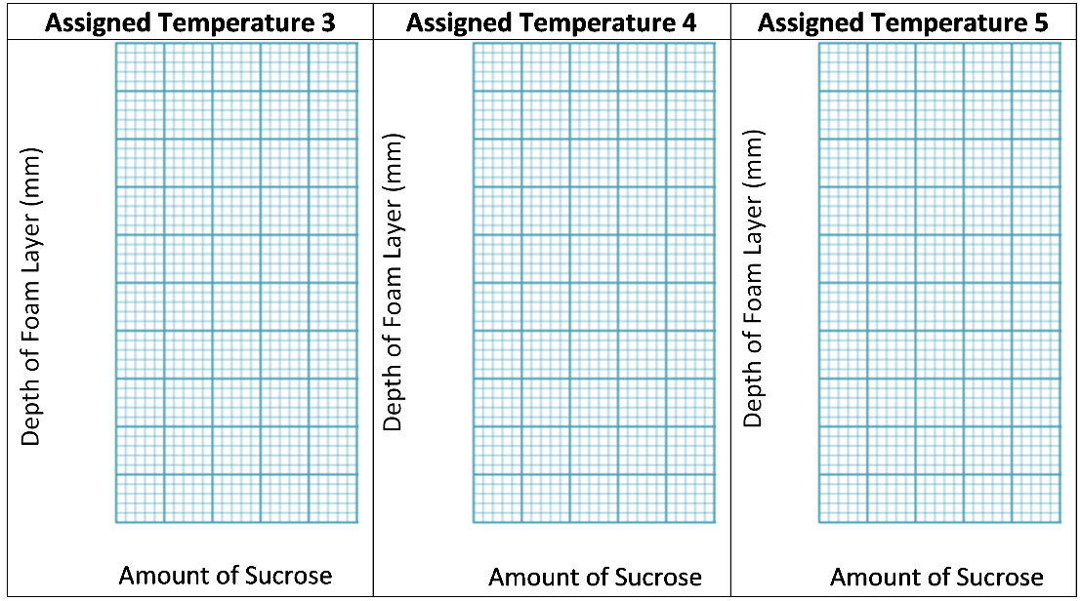
25. Interpret the results shown in the graphs in question 24a. What effects did different amounts of sucrose have on the amount of CO₂ produced?

26. This graph shows the expected relationship between sucrose concentration and rate of CO₂ production. Circle the part of the graph that most closely resembles your graphs in question 24a. If you are not sure which part of the graph to circle, explain your uncertainty.

Jim Baker asked your class to find “the least amount of sucrose that will result in maximum CO₂ production”. This criterion was intended to ensure that the bread would be fluffy, but it wouldn’t be too sweet. However, it’s unclear what the trade-off should be between maximum production of CO₂ bubbles and not too sweet. Should the criterion be set at A or B or some other value?

27a. What would be an advantage of using point A as the criterion for sucrose concentration?

27b. What would be an advantage of using point B as the criterion for sucrose concentration?

28a. Suppose Jim Baker told you to choose point A for the ideal sucrose concentration to meet his design challenge. What advice would you give him concerning the optimum temperature and optimum amount of sucrose per 80 mL of water? Include cautions about any uncertainties that result from the limitations of your class’s data.

28b. Describe any additional testing you would recommend to improve your advice.

28c. Would you advise continued testing with the procedures you have been using, or would you advise Jim Baker to begin testing with bread dough? What are the relative advantages and disadvantages of these two ways of testing different possible design solutions?

By Dr. Ingrid Waldron and Dr. Jennifer Doherty, Department of Biology, University of Pennsylvania, © 2024. These Teacher Preparation Notes and the related Student Handouts are available at https://serendipstudio.org/sci_edu/waldron/#fermentation.
If you want to provide your students with additional background for understanding energy metabolism, including cellular respiration and photosynthesis, see "Cellular Respiration and Photosynthesis – Important Concepts, Common Misconceptions and Learning Activities" (https://serendipstudio.org/exchange/bioactivities/cellrespiration).
Quotations are from http://www.nextgenscience.org/sites/default/files/HS%20LS%20topics%20combined%206.13.13.pdf and https://www.nextgenscience.org/.
If you plan to omit the bioengineering design challenge, you will want to use the shorter Student Handout. You can omit the warm water bath (which is needed to equalize the temperature in different cups in Part III). Also, if you don't have thermometers, your students can just use water and killed yeast suspension that is warm to the touch.
Scales are desirable since it is easier to accurately measure 4 g of yeast and 0.5 g of sucrose, but if you do not have scales, you can substitute 1.5 teaspoons of yeast (4.3 g) and 1/8 teaspoon of sucrose (0.5 g) in the instructions on page 3 of the Student Handout and purchase cooking measuring spoon sets. (Make sure to purchase measuring spoon sets with spoons for 1, 1/2, and 1/8 teaspoons.) You will also want to supply something like plastic knives, so students can use the back of a knife to level off each volume measure.
One teacher has reported success using a hotplate with a 1000 mL beaker filled with warm water, with the hotplate set to maintain a constant temperature throughout the lab. This teacher used 50 mL test tubes instead of cups. For the experimental test tube, the students measured 20 mL of water, 1.0 g of yeast, and 0.2 g of sugar. If you have weighing dishes, obviously the students can use them instead of scrap paper.
In our pilot testing, we found that the foam layer produced by 100 mL of water with 5 g of yeast tended to overflow the 10-ounce cups, which is why we recommend using 80 mL of water with 4 g of yeast.
Some types of bread are made with baking powder or baking soda which produce CO₂ through a simple chemical reaction.
Your students can further explore whether yeast grains are alive by testing whether yeast grow on nutrient agar plates (https://serendipstudio.org/sci_edu/waldron/#yeast).
You may want to point out to your students that the ethanol which is added to gasoline is produced by alcoholic fermentation. (Background information is available at https://en.wikipedia.org/wiki/Ethanol_fuel and classroom activities are available at https://www.glbrc.org/education/classroom-materials/cb2e-converting-cellulosic-biomass-ethanol.) For information about lactic acid fermentation during physical activity, see our analysis and discussion activity, "How do muscles get the energy they need for athletic activity?" (https://serendipstudio.org/exchange/bioactivities/energyathlete).
Notice that aerobic respiration generates ~29 molecules of ATP for each glucose molecule; this number is less than previously believed (and still often erroneously stated in some textbooks). This revised estimate is based on newly discovered complexities and inefficiencies in the function of the electron transport chain and ATP synthase enzyme. The number of ATP produced per molecule of glucose is variable because of variability in the efficiency of the electron transport chain proton pumps and the ATP synthase (https://iubmb.onlinelibrary.wiley.com/doi/epdf/10.1002/bmb.2003.494031010178). These recent findings are interesting as an example of how science progresses by a series of successively more accurate approximations to the truth.
If you show this video, you will want to point out that, at about 2.5 minutes, the explanation of the function of lactase is not accurate since it says that lactase splits the disaccharide lactose into monosaccharides which can be "digested", when it should say the monosaccharides can be "absorbed into the blood".
It will be desirable for students to have additional engineering design experiences in the broader curriculum, including additional components of the engineering design process (e.g., multiple rounds of developing proposals and testing them in order to develop the best Design Solutions). Descriptions of a more complete engineering design process are available at https://sedl.org/pubs/classroom-compass/cc_v2n3.pdf and https://nap.nationalacademies.org/catalog/12635/engineering-in-k-12-education-understanding-the-status-and-improving (especially the summary and chapter 5).
The Student Handout states that you can predict the effects of temperature and sucrose concentration on the multiple-enzyme process of alcoholic fermentation by thinking about the effects on a single enzyme-catalyzed reaction. This simplification can be thought of as reflecting the expected effects on the rate-limiting reaction in alcoholic fermentation.
The rate of bread dough rising can also be influenced by the other ingredients in the dough.

