Teacher Preparation Notes for
How do we sense the flavors of food?

In this minds-on activity, students develop science practice skills by developing plans for a hands-on investigation, carrying out the investigation, analyzing the data, and interpreting the results. Then, students answer analysis and discussion questions as they develop a basic understanding of how taste and olfactory receptor cells function and how sensory messages to the brain contribute to flavor perception and flavor-related behavior.

This activity will probably take two 50-minute periods, the first period for pages 1-3 of the Student Handout (including gathering the data) and the second period for pages 4-8 of the Student Handout (including analyzing and interpreting the data).

Table of Contents

Learning Goals – page 1

Supplies – pages 2-3

Preparing for the Investigation – page 3
Instructional Suggestions and Background Information

General Instructional Suggestions – page 3

Section I. Introduction – page 4

Section II. Investigation Procedure – pages 4
Section III. Analysis and Interpretation of Results – page 5
Section IV. Sensory Receptors, Brain and Behavior – pages 6-7
Section V. Conclusions – page 7

Optional Extension – Inquiry Investigations – page 7

Additional Resources (including Data Tables) – page 7-9

Learning Goals
In accord with the Next Generation Science Standards:
- This activity helps to prepare students for the Performance Expectation:
- MS-LS1-8. "Gather and synthesize information that sensory receptors respond to stimuli by sending messages to the brain for” perception, “immediate behavior and/or storage as memories.”
- Students learn the Disciplinary Core Idea:
- LS1.A: From Molecules to Organisms: Structures and Processes – "Each sense receptor responds to different inputs (electromagnetic, mechanical, chemical), transmitting them as signals that travel along nerve cells to the brain. The signals are then processed in the brain, resulting in” perceptions, “immediate behaviors and/or memories.”
- Students engage in the Science Practices:
- "Planning and carrying out investigations"
- "Analyzing and interpreting data"
- “Constructing explanations”
- “Engaging in argument from evidence”.
- This activity provides the opportunity to discuss the Crosscutting Concepts:
- Cause and effect: Mechanism and explanation
- Structure and function.
Supplies
- disinfectant cloths to clean tables or desks and goggles (and also to clean hands if your students will not have access to a sink to wash their hands)
Quantities are per pair of students in your largest class
- one blindfold or pair of goggles with construction paper covering the lens (One-piece safety goggles are easier to cover than two-piece swimming goggles.)
- one timer to keep track of seconds
- one bottle with drinking water
Quantities are per pair of students for each class
- two gloves
- two medium-size cups (for a water rinse before each sample)
- three 3-ounce cups (to taste liquid samples)
- four plastic spoons (to taste solid samples)
- one container or small trashbag to hold used spoons and cups and one container for any samples that subjects may spit out after tasting
- seven Styrofoam or paper cups covered with aluminum foil to hold sucrose solution and the six samples on trays
- samples – (For liquids, you will want approximately three tablespoons (~45 mL) per pair of students; for candy samples, one per pair of students; for Jell-O or pudding, approximately one heaping teaspoon (6 mL) per pair of students.)
- A = sucrose solution (4 teaspoons sucrose (table sugar) per cup of water = ~19 g sucrose per 240 mL of water) (This is the sample that we recommend you use when you guide the students in your class through the procedure at the beginning of data collection; see page 3 of the Student Handout.)
Tray B-D
- B = diluted lemon juice (4 teaspoons of lemon juice per cup of water = 20 mL lemon juice in 240 mL water)
- C = lime Jell-O (It may help to make the Jell-O a little less solid than called for in the package instructions. You may prefer the pre-made Jell-O in multi-packs. For your Jewish or Muslim students, make sure to get Jell-O that is labeled as kosher.)
- D = vanilla pudding (We have had success with Jell-O brand instant pudding and with pre-prepared multipacks.)
Tray E-G
- E = salt water (½ teaspoon salt in 1 cup water = 2 g salt per 240 mL of water)
- F = cherry Starburst Fruit Chew (but not for anyone who has braces!)
- G = lemon Starburst Fruit Chew (also not for anyone who has braces)
If you prepare the samples ahead of time, store them in a refrigerator or cooler (except for the candies).
- one Data Table (You can photocopy the last page of these Teacher Preparation Notes and cut each copy in half to provide two Data Tables. If you prefer, you could use a landscape orientation and enlarge the table to allow more room for comments)

Preparing for the Investigation
- Take the samples out of the refrigerator to warm up ~60 minutes before beginning the investigation.
- If you can, it is better to set up the investigation in a classroom, since students generally should not eat or drink in the laboratory. Clean the desks, tables or lab benches thoroughly with disinfectant cloths.
- For each pair of students, set up:
  - a bottle of water
  - two medium-sized cups for water
  - a covered cup with sucrose solution (labeled A)
  - three 3-ounce cups
  - four spoons
  - two gloves
  - a timer
  - a container or small trashbag for used cups and spoons and a container for any samples that subjects may spit out after tasting
  - a data sheet.
- Set up the two types of tray described on page 2, with the samples in covered cups labeled with the appropriate code letters. You will need one pair of trays for each four students in your class. Half the pairs of students will use Tray B-D first and half will use Tray E-G first.

General Instructional Suggestions
As background for this activity, students should understand that all matter is made up of molecules.

To maximize student participation and learning, I recommend that you have students work on groups of related questions individually or in pairs before having a class discussion of their answers.

In the Student Handout, numbers in bold indicate questions for the students to answer. In these Teacher Preparation Notes,
- indicates a step in the investigation procedure for the students to do.

If you use the Word version of the Student Handout to make changes for your students, please check the PDF version to make sure that the figures and formatting in the Word version are displaying correctly on your computer.

A key is available upon request to Ingrid Waldron (iwaldron@upenn.edu). The following paragraphs provide instructional suggestions (including the procedure for the investigation) and background information.

Instructional Suggestions – Section I. Introduction
In common usage, taste and flavor are often used interchangeably. In contrast, for this investigation it is important for students to distinguish between flavor and taste (see the top of page 1 of the Student Handout).

Your class discussion of question 1 should focus on the students’ opinions and their reasons for these opinions, as a lead-in to the investigation. If questions, disagreements or inaccuracies arise, try to frame these as questions to be answered by the investigation or by additional information presented after the investigation. To maintain the spirit of inquiry, postpone discussion of the scientific evidence and conclusions until discussion of pages 6-7 in the Student Handout after the investigation has been completed and the data have been analyzed.

On page 1 of the Student Handout, the figure and question 2 provide the basis for students to begin to design an investigation procedure and interpret the results of the investigation. Understanding how odor molecules get from the mouth to the nose illustrates the Crosscutting Concept: Structure and function. For question 3, students should recognize that the contribution of smell will be evaluated by comparing flavor with taste only to flavor with both taste and smell.

If you use different samples from the ones suggested under Supplies, you may need to change the first column of the table in question 4. Questions 5-7 will help your students understand specific procedures to improve the validity of the data and the safety of the subjects. If students have trouble answering question 6, you may want to give them hints such as “If you had red and yellow candies, which one would you think had a lemon flavor?” (for the first row of the table).

Instructional Suggestions – Section II. Investigation Procedure
If a student should not eat the samples, he/she can be an experimenter and his/her partner can be a subject for all the samples.

If you have an odd number of students in your class, you can have a group of three students with experimenter duties split, so experimenter 1 provides water and samples and experimenter 2 keeps track of time, reads the instructions, and records the subject’s responses. This division of labor has the advantage of more reliably maintaining sanitary precautions. However, I do not recommend having three students in each group, since this results in fewer groups and less data; the variability in subjects’ responses for some of the samples makes it desirable to have as much data as possible for analysis.

To help your students understand the procedure on page 3 of the Student Handout, guide them through the procedure for sample A.

Collect the Data Tables at the end of period 1 and photocopy them for the student analysis groups to use during the Analysis and Interpretation of Results. You will need at least four analysis groups in each class, since each group will analyze the data for one liquid and one solid sample and there are four solid samples (C, D, F and G). It is desirable to have more than one group analyze the data for each sample, particularly for the solid samples, which yield more variable data. You will need a copy of each data sheet for each analysis group.

Instructional Suggestions – Section III. Analysis and Interpretation of Results
Organize your students in groups for data analysis, and assign samples for each group to analyze. Each group will use their data sheets to answer questions 8-16. Since the solid samples yield more variable results, it will be desirable to have more than one group analyze the data for each solid sample; that way, you can compare the conclusions reached by different groups and discuss differences in interpretation of the data. (Differences in interpretation also cause disagreements between scientific researchers.)

Questions 8-16 should be answered on the basis of evidence from the data sheets from their investigation. Make sure that students understand that science progresses by the accumulation of evidence rather than assuming you know what the results should be! Scientific errors such as the erroneous taste map of the tongue (http://theconversation.com/that-neat-and-tidy-map-of-tastes-on-the-tongue-you-learned-in-school-is-all-wrong-44217) can persist when conclusions are based on assumptions rather than actual evidence.

Of course, there is good reason to be skeptical and consider sources of error when the results of an investigation conflict with previous research results. In response to question 17, students should suggest possibilities such as:
- Odor molecules may have reached a subject’s nose even though they were holding their nose (e.g. if they were not holding their nose tightly or breathed out slightly).
- Some students may have difficulty accurately reporting taste and flavor perception within 10 seconds.
- Some subjects might have been influenced by what they expected to find.
- Scientists have established that there are genetic differences between different people (e.g. differences in the ability to detect certain bitter tastes).
During discussion of question 17, you should ask students to identify sources of error and variation that could account for the variation in the data for the samples they analyzed.

While students are answering question 17, each student group will enter their results in a master copy of the table in question 16; use this master copy to display the class data. (You may want to use Google Apps for Education for this purpose.) To answer questions 18 and 19, students should look for patterns across the different samples in the second and third columns respectively in the table in question 16. As you discuss student answers to questions 18 and 19, ask students how confident they are of their conclusions and discuss possible sources of error.

In discussing question 20, encourage students to think about what they have learned from their investigation. You may also want to discuss limitations of the investigation. For example, you may want to ask your students, “What additional samples would you want to test? What more would you expect to learn about the contributions of taste and smell to flavor perception?”

Instructional Suggestions and Background Information
– Section IV. Sensory Receptors, Brain and Behavior
You may want to point out to your students that the bumps they can see on their tongues are papillae. Taste buds are much smaller structures on the surface of the papillae. Food molecules dissolve in the saliva and are carried down to the taste buds where they can bind with taste receptor molecules on the tips of the taste receptor cells in the taste pore.  Taste and smell are chemical senses. Specific types of food molecules bind with taste receptor molecules for sweet, bitter or savory (hearty or umami; pronounced oo-MOM-ee). For example, sucrose binds with the taste receptor molecule for sweet and amino acids (such as the glutamate in MSG) bind with the taste receptor molecule for savory. Similarly, specific types of odor molecules bind with specific olfactory receptor molecules. Sour and salty taste receptor molecules appear to be ion channels (for H+ and Na+, respectively). | 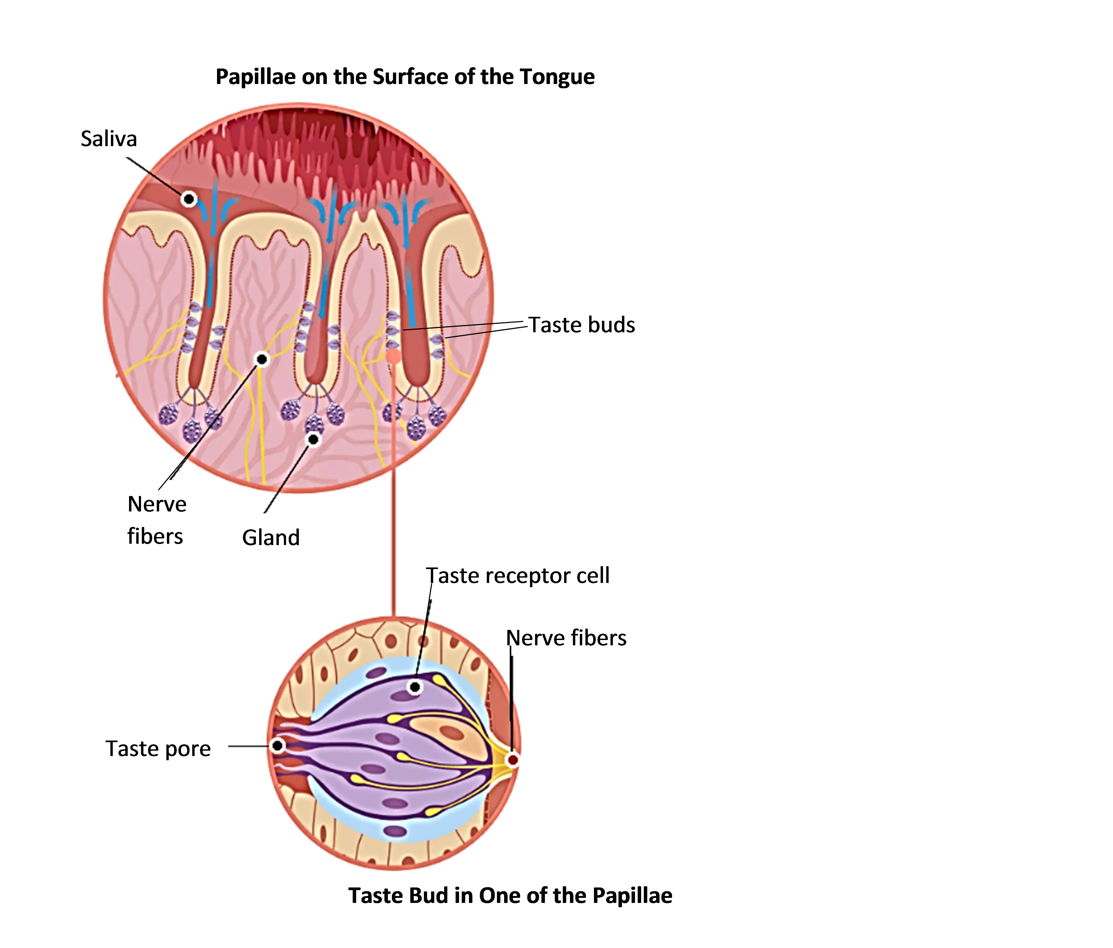  (https://www.dkfindout.com/us/human-body/senses/taste/)

In the mouse experiments described before question 22, researchers found that the nerve fibers from each type of taste receptor go to a slightly different part of the mouse brain. These researchers developed a technique to stimulate these different areas of the brain in an awake mouse that can drink water or show other behavior. When the researchers stimulated the part of the cortex that receives input from sweet taste receptors, the mice responded as though they were tasting sweet (e.g. non-thirsty mice were induced to drink plain water). When the researchers stimulated the part of the cortex that receives input from bitter taste receptors, the mice responded to plain water as though it contained bitter substances. Additional information is available at https://www.nih.gov/news-events/nih-research-matters/how-taste-perceived-brain.

When discussing student answers to question 22, it will be important for students to understand why the triangle they are asked to draw should include part of the brain. If your students are familiar with the term neuron, you will probably want to substitute “neuron” for “nerve cells” in the description and questions on pages 7-8 of the Student Handout.

The five basic tastes provide useful guidance for behavior. Both sweet and savory (umami or hearty) indicate useful sources of nutrition, since these taste indicate the presence of sugars and amino acids, respectively. Question 23 engages students in thinking about this phenomenon; if your students are familiar with natural selection, you should include natural selection in your discussion of this question. Bitter taste can warn of toxic or spoiled foods. Low concentrations of NaCl are attractive, whereas high salt concentrations are aversive, and this corresponds to the need for modest sodium intake. However, taste is a fallible guide to good nutrition, particularly in our current environment of abundant highly palatable foods.

After discussing the information and questions on page 7 of the Student Handout, I recommend that you discuss the Crosscutting Concept, Cause and effect: Mechanism and explanation. “Events have causes, sometimes simple, sometimes multifaceted. A major activity of science is investigating and explaining causal relationships and the mechanisms by which they are mediated.” This Crosscutting Concept is illustrated by the sequence that begins with the binding of food molecules to receptor molecules, which stimulates the olfactory and taste receptor cells, which in turn stimulate activity in nerve cells, which can result in appropriate food-related behaviors and flavor sensations.

Instructional Suggestions – Section V. Conclusions
Question 26 can be used for summative assessment. Very soon after students complete this question, it will be helpful to have a discussion to reinforce student understanding and correct any misconceptions.

Optional Extension – Inquiry Investigations
Inquiry instruction involves “students in a form of active learning that emphasizes questioning, data analysis, and critical thinking” (http://www.nsta.org/publications/news/story.aspx?id=50983). The Student Handout presents a structured inquiry activity.

For an open inquiry activity, students can develop their own questions to investigate. They can use materials and procedures similar to the investigation in the Student Handout in order to investigate questions such as:
- Does vision influence the perception of flavor?
- How does the perception of taste or flavor change as concentration changes or when you combine samples?
- Is the sweetness the same for different types of sugars at the same concentration?
- How does the perception of flavor change as you continue to chew or suck on a sample?

Suggestions for guiding students in successful open inquiry investigations are available at http://mitep.mtu.edu/include/documents/Rethinking-Laboratories-_-Volkmann.pdf and http://www.nsta.org/publications/news/story.aspx?id=50983.

Another inquiry activity would be to have students search reliable sources for information concerning their questions on taste, olfaction, and the perception of flavor. Useful sources include those listed below. A useful guide for “Evaluating Internet Research Sources” is available at http://www.virtualsalt.com/evalu8it.htm.

Good Sources of Additional Information on Taste, Smell and Flavor
- “Taste, Our Body’s Gustatory Gatekeeper” (https://dana.org/Cerebrum/2005/Taste,_Our_Body%E2%80%99s_Gustatory_Gatekeeper/)
- “Our Chemical Senses: 2. Taste” (http://faculty.washington.edu/chudler/taste.html)
- “Your Nose” (http://kidshealth.org/en/kids/nose.html)
- “Making Sense of Scents: Smell and the Brain” (http://brainfacts.stage.sfn.org/sensing-thinking-behaving/senses-and-perception/articles/2015/making-sense-of-scents-smell-and-the-brain/)
- “The Molecular Logic of Smell” (https://www.scientificamerican.com/article/the-molecular-logic-of-smell-2006-09/)
- “How does the way food looks or its smell influence taste?” (https://www.scientificamerican.com/article/experts-how-does-sight-smell-affect-taste/)

Sources for Figures in the Student Handout
- Nose figure on page 1, modified from http://blog.monell.org/wp-content/uploads/2016/05/Ortho-vs-Retro.jpg
- Sensory integration figure on page 7, modified from https://media1.britannica.com/eb-media/79/126079-004-DC09312C.jpg
Data Table for ____________________ and _______________________ (names)

Sample | Taste while  holding nose closed | Flavor  with nose open | Comments, including  any change noticed when let go of nose  or what subject thinks the sample is
A
B
C
D
E
F
G

Data Table for ____________________ and _______________________ (names)

Sample | Taste while  holding nose closed | Flavor  with nose open | Comments, including  any change noticed when let go of nose  or what subject thinks the sample is
A
B
C
D
E
F
G

By Dr. Ingrid Waldron, Department of Biology, University of Pennsylvania © 2017. These Teacher Preparation Notes and the related student handout are available at http://serendipstudio.org/sci_edu/waldron/#senses . I am grateful to Nabeehah Parker and Jake Zimny for their very helpful suggestions for improvements.
Quotations are from http://www.nextgenscience.org/
We have had the best success with the specific samples listed. Other possibilities include: - 4 teaspoons vinegar per cup of water or 20 mL vinegar per 240 mL water (apple cider vinegar is preferred because it should allow students to detect the vinegar smell, whereas white vinegar may just taste sour with or without smell) - other flavors of Starburst Fruit Chews - orange or strawberry Jell-O. - lemon or chocolate Jell-O brand instant puddings - jellybeans, but you should pretest to pick out the flavors that are identifiable and to determine the best number of jellybeans to include in a sample.
Starburst fruit chews are wrapped, and it can be tedious to unwrap all the needed candies. We have not tried Starburst minis which are not wrapped; online reviews suggest that perhaps the flavors for the minis are not the same as the regular Starburst fruit chews, so I don't know how well they would work. I welcome your feedback (iwaldron@upenn.edu).
Although this is not clearly shown in the figure, there are two olfactory bulbs, one above each nasal cavity.
This short interval was chosen to minimize the risk that odor molecules may have diffused up into the nose.
Quotation from http://www.nextgenscience.org/sites/default/files/Appendix%20G%20-%20Crosscutting%20Concepts%20FINAL%20edited%204.10.13.pdf .

