Teacher Preparation Notes for Is Yeast Alive?

In this activity, students evaluate whether little dry grains of yeast are alive by testing for metabolism and growth. A recommended alternative activity is "Alcoholic Fermentation in Yeast – A Bioengineering Design Challenge" (http://serendipstudio.org/sci_edu/waldron/). This multi-part minds-on, hands-on activity helps students to understand both alcoholic fermentation and the engineering design process. Students begin by learning about yeast and alcoholic fermentation. To test whether grains of yeast can carry out alcoholic fermentation, students compare CO₂ production by grains of yeast in sugar water vs. two controls. The last part of this activity presents the bioengineering design challenge where students work to find the optimum sucrose concentration and temperature to maximize rapid CO₂ production. Structured questions guide the students through the basic engineering steps of specifying the design criteria, applying the relevant scientific background to the design problem, and then developing and systematically testing proposed design solutions.

Table of Contents
Learning Goals – page 1
Equipment and Supplies – pages 1-2
Teacher Preparations – pages 2-3
Introductory Discussion and Question for This Activity – pages 3-4
Possible Addition to the Yeast Experiments – page 4
Discussion of Yeast Metabolism – pages 4-5
Suggested Follow-Up Questions and Discussion – Characteristics of Life As Emergent Properties – pages 5-6

Learning Goals
- The characteristics of life include using energy (i.e. metabolism), ability to grow and develop, reproduction, homeostasis, response to the environment, evolutionary adaptation, composed of one or more cells, and has genetic material. (Only the first two are tested in these experiments.)
- The first experiment indirectly tests for the ability to metabolize, i.e. utilize energy. When sugar is available, the yeast metabolizes the sugar and produces carbon dioxide, a gas which accumulates in the balloons and causes them to get bigger.
- Replication of each experimental condition is useful to be more confident of your results, since experimental results are often variable even when you try to maintain the same conditions.
- The second experiment tests for the ability to grow.
- Some things that look dead are actually alive in dormant forms that can survive long periods in difficult environments (e.g. too dry or lacking in food), until the environment improves and provide the conditions needed for active metabolism and growth.

Equipment and Supplies:
Baker’s yeast (preferably rapid rising super active; make sure the yeast has not reached its
expiration date) (see Teacher Preparations 1)
Sugar (see Teacher Preparations 1)
Plastic zip-lock baggies (2 per group)
Small water balloons (4 per group) (see Teacher Preparations 1)
Test tubes, between 15-25 mL (4 per group)*
Test tube rack (1 per group)
Container for water that will hold at least 100 mL (1 per group)
Gloves (optional, ~2 per group)
Sharpies (1 per group)
Sterile nutrient agar plate (1 per group) (see Sterile Nutrient Agar Plate Preparation, pages 2-3) ⁺
Microscope(s), slides and coverslips (2-4 per group) ⁺

*If you do not have test tubes, you can use the plastic tubes that are used to hold single cut
flowers or very small bottles which have narrow necks that will fit into the ends of the water balloons (making appropriate minor modifications in pages 1-3 of the Student Handout). Take care to keep the volume of whatever container you chose small enough so it and the balloons fill up with carbon dioxide within 25 minutes using a reasonable amount of yeast.

⁺If you have only very limited budget and equipment, you can omit the procedure to test growth and just have the students do the introduction and test for metabolism. If you do not have access to reasonable quality compound microscopes (yeast cells are 5-10 μm in diameter), this lab activity can be done just as well by simply omitting step 6 on page 4 of the Student Handout or you may want to use instructions readily available online that allow you to use a cell phone as a microscope.

Teacher Preparations:
- You will need to experiment with your yeast and size of test tube to determine how much yeast you need for four test tubes. We have found that approximately 1 g of yeast and 1.5-2 g of sugar per 25 mL test tube provide good results. 1 sugar packet is 4.3 g of sugar. For best results, use small water balloons and make sure the seal between the test tube and water balloon is tight. If you use large test tubes (100ml or greater) regular sized balloons work well.
- At least one day before class, prepare one Petri dish of yeast growth medium per group, as described in the following section.
- At the beginning of class, have ready group kits of 4 test tubes, 4 balloons, 1 zip-lock bag with an appropriate amount of yeast and another zip-lock bag with an appropriate amount of sugar, together with a test tube rack, sharpie, and container for the students to get warm water. You may want the students to wear gloves then they shake their test tubes to mix the yeast.
- For experiment 2, have the students use only 10-12 grains of yeast and a small amount of water. If incubating at room temperature allow 3-4 days for growth. If you can incubate at 37º C, then overnight will be sufficient.

Sterile Nutrient Agar Plate Preparation:
There are three ways of obtaining sterile nutrient agar plates. You will want YPD agar with ingredients comparable to the recipe provided at http://cshprotocols.cshlp.org/content/2010/9/pdb.rec12315.full?text_only=true. Although options 1 and 2 below are more expensive, we recommend them if you do not have experience preparing sterilized media.
- Buy plates that are pre-poured with sterile nutrient agar.
- Buy solid sterile nutrient agar medium that you microwave to liquefy and then pour into sterile Petri dishes. See pouring instructions below.
- Prepare sterile nutrient agar from powder using an autoclave or a stove-top pressure cooker and then pour into sterile Petri dishes. Simply boiling the agar is not sufficient for sterilization and your plates will be contaminated with bacteria. To do this, add the appropriate amount of nutrient agar and distilled water (see table below) into a flask or glass bottle and cover with aluminum foil. When using an autoclave or pressure cooker always use a container that is twice the volume of the liquid you are sterilizing. To sterilize the solution you want to keep the autoclave or pressure cooker at 15 psi for 20 minutes. To use the pressure cooker, add about 1” of water to the pot, place the covered glass container in the pot, and close and lock the lid. Following the instructions for your pressure cooker, start timing 20 minutes after the pressure cooker has reached the right pressure. After sterilizing, use caution when removing the pressure cooker lid so you do not get scalded with steam. Let the agar cool to 50ºC before pouring plates.
Nutrient Agar + Distilled Water = Yield
Nutrient Agar | Distilled Water | Yield
23 g | 1000 ml | 50 plates
11.5 g | 500 ml | 25 plates
9.2 g | 400 ml | 20 plates
4.6 g | 200 ml | 10 plates

Pouring Plates:
When pouring sterilized media into sterile Petri dishes it is important to always keep the agar covered and the lid on the Petri dish unless you are actively pouring in agar in order to avoid contamination.
- Pour enough of the sterilized agar medium (cooled to approximately 50ºC) into each sterile plastic Petri dish to cover the bottom—about 1/8" to 1/4" deep. You do not need to remove the cover of the plate completely; you can just lift the lid enough to pour in the agar. When you have poured the plate lower the lid immediately. If the medium solidifies before you finish pouring, it can be reheated in the microwave.
- Place the covered agar plates on a countertop to cool and solidify. Agar medium will set like stiff gelatin at room temperature.
- The agar medium is now ready for storage or use. Storage: Do Not Freeze! Stack agar plates upside down in the refrigerator. The purpose of placing the plates upside down is to prevent condensation from dripping down onto the agar surface which could then facilitate movement of organisms between colonies. If plates have been refrigerated, set them out and allow them to warm to room temperature before using them.

Introductory Discussion and Question for This Activity
To begin, we encourage you to ask your students
"What characteristic(s) distinguish living things from things that are not living?"
During the class discussion of student answers, you may want to probe their answers to ask for definitions of terms they use. You may also want to foster discussion by asking whether items that share some of the characteristics of living organisms are alive (e.g. a flame, a stream, a piece of lumber, or a crystal that grows in a solution). It will become obvious that no single characteristic distinguishes living organisms from things that are not alive.

As formative assessment, you may want to have individual students or pairs of students answer the question below.

Fill out the table below. List the major characteristics of life, and explain how a dandelion and a flame show each characteristic of life or, if either a dandelion or a flame doesn’t show a particular characteristic of life, write. No

Characteristic of Life | Dandelion | Flame

Possible Addition to the Yeast Experiments
If your students can use boiling water, they can design additional experiments to test whether treating the grains of yeast with boiling water kills them and prevents subsequent metabolism and growth. This provides further evidence that the production of gas and growth occurred because the yeast grains were alive. However, this only works if the yeast grains are treated with water which is boiling or very close to boiling and not merely hot.

Discussion of Yeast Metabolism
The yeast which is used to make bread is Saccharomyces cerevisiae. This yeast is a facultative anaerobe, which means that when oxygen levels are low or glucose levels are high, sugar is metabolized without using oxygen, resulting in the production of a small amount of ATP, as well as carbon dioxide and ethanol. As the bread bakes, the ethanol evaporates. Bubbles which contained carbon dioxide provide the fluffy texture of bread. Saccharomyces cerevisiae and other members of the same genus are used in making wine and beer, where, obviously, the production of alcohol is a major goal.

An alert and well-informed student may point out that in aerobic cellular respiration, although CO₂ is generated, an equal number of molecules of O₂ are consumed, so there is no net increase in gas molecules.
represents a chemical reaction

\/ represents energy transfer between
\/ coupled reactions
C₆ H₁₂O₆ + 6 O₂ 6 CO₂ +6 H₂O
\/
\/
~29 ADP + ~29 P_{i} ~29 ATP

To respond to this observation, it is important to understand the difference between aerobic cellular respiration and anaerobic alcoholic fermentation. As shown in the figure below, the first major step in producing ATP is glycolysis. When oxygen is available, cells can use the Krebs cycle (citric acid cycle) and the electron transport chain to make up to 27 ATP molecules. This is called aerobic respiration.

Yeast cells commonly use a process called fermentation. Fermentation does not produce additional ATP, but it restores molecules needed for glycolysis to continue. Fermentation in yeast cells produces ethanol and CO₂.
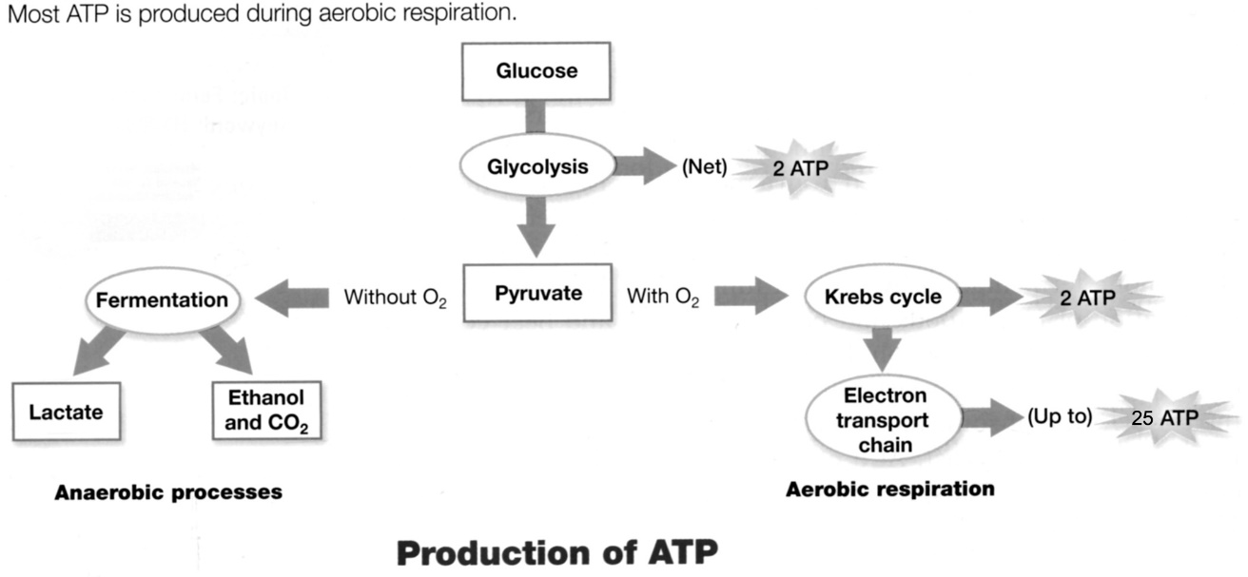
(Figure revised from Johnson and Raven, 2004, Biology, Holt Rinehart and Winston, p. 110)

Since anaerobic alcoholic fermentation results in the production of much less ATP per glucose molecule than aerobic respiration, it may seem puzzling that Saccharomyces cerevisiae often use anaerobic fermentation even when oxygen is available. However, the production of ethanol
which spills over into the environment appears to give S. cerevisiae a competitive advantage, since S. cerevisiae is more tolerant of ethanol than many other microorganisms. Also, S. cerevisiae is able to adopt a make-accumulate-consume ethanol strategy in which S. cerevisiae use alcoholic fermentation to rapidly metabolize glucose and produce ethanol during an initial growth phase and then switch to metabolizing ethanol when the glucose supply has been depleted. The figure shows this phenomenon in a laboratory setting; the same phenomenon appears to occur in fruits in nature. | (diamonds = glucose; triangles = biomass of  Saccharomyces cerevisiae; squares = ethanol;  Piskur et al., 2006, Trends in Genetics)

Suggested Follow-Up Questions and Discussion
– Characteristics of Life as Emergent Properties

Have your students answer these three questions.

1. If you took all the molecules in a bacterium and mixed these molecules in a mini test tube, would this mixture of molecules be alive?

2. Describe the differences between a bacterium that is alive and the mixture of molecules from a bacterium?

3. Explain how this example illustrates emergent properties.

These questions will guide students in thinking about how the characteristics of life emerge at the level of the cell. For example, the ability to reproduce or use energy depends on the way molecules are organized and interact within the cell. Scientists cannot predict how cells function by simply studying molecules, in part because there are an extremely large number of molecules in a cell, but also because the molecules in a cell are highly organized in ways that allow the characteristics of life to emerge.

By Dr. Ingrid Waldron and Dr. Jennifer Doherty, Department of Biology, University of Pennsylvania, 2019. These Teacher Preparation Notes and the related Student Handout are available at http://serendipstudio.org/sci_edu/waldron/.

