Dragon Genetics
-- Independent Assortment and Genetic Linkage

This activity, by Dr. Ingrid Waldron and Jennifer Doherty, Department of Biology, University of Pennsylvania, © 2008,
incorporates ideas from Dragon Genetics Lab, 2002, Bob Farber, Central High School, Philadelphia, PA and
Dragon Genetics by Dr. Pamela Esprivalo Harrell, in the January 1997 issue of Science Scope, 20:4, 33-37.

In this activity you will study the patterns of inheritance of multiple genes in (imaginary) dragons. These dragons have two pairs of homologous chromosomes in each cell. You will see that, since genes are carried on chromosomes, the patterns of inheritance are determined by the behavior of chromosomes during meiosis and fertilization.

The Law of Independent Assortment
-- Inheritance of Genes on Different Chromosomes

For this activity, we will only consider one gene on each chromosome. These genes are described in the following table.
 |  | Dominant Alleles |  | Recessive Alleles
Chromosome 1 |  | W = has wings |  | w = no wings
Chromosome 2 |  | H = big horns |  | h = small horns

The mother dragon is heterozygous for the wing gene (Ww) and the horn gene (Hh). The father is homozygous recessive for the wing gene (ww) and the horn gene (hh). What phenotypic traits will each parent have? (Phenotypic traits are the observable bodily characteristics.) Draw the appropriate characteristics for each parent.

Mother Father
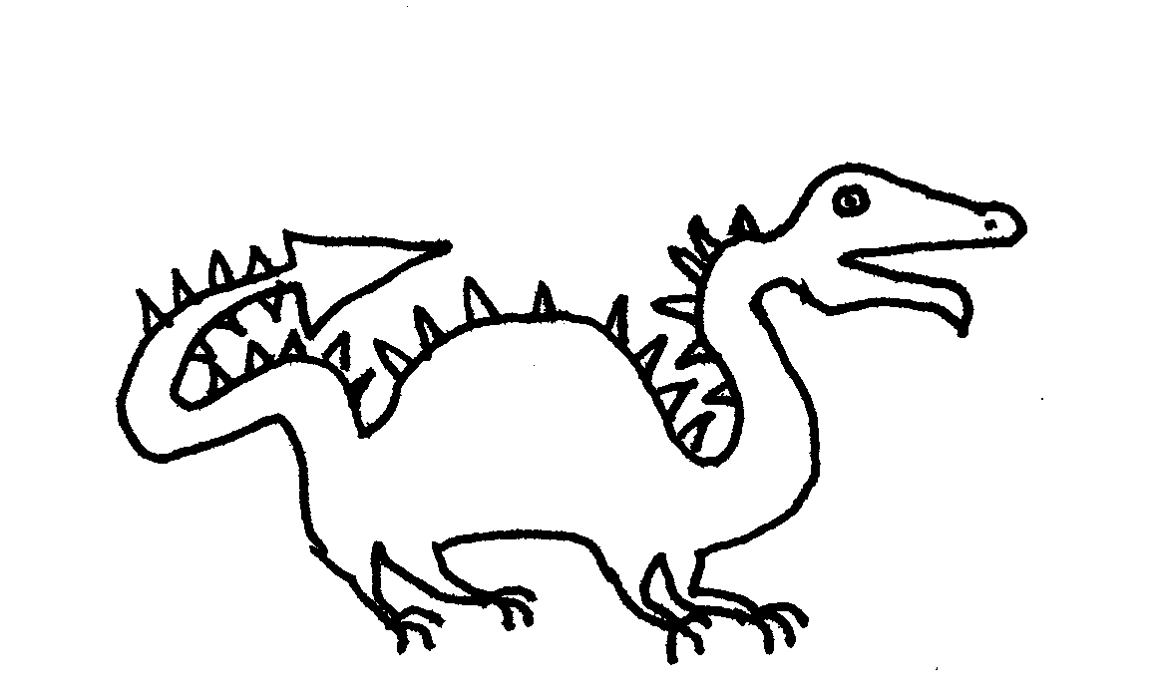

Review of Inheritance of Single Genes

Draw a Punnett Square to show the inheritance of the horn alleles for a mating between this mother and father.

On average, what fraction of the baby dragons will have big horns?
Predictions of Inheritance of Two Genes on Different Chromosomes

To predict the inheritance of the wing and horn genes, you first need to determine the genotypes of the eggs produced by the heterozygous (WwHh) mother dragon and the sperm produced by the homozygous (wwhh) father dragon. Considering both the wing and horn genes, what different genotypes of eggs could the heterozygous mother dragon produce? Use the figure below to answer this question.

Notice that, in a cell that is prepared for meiosis 1, the homologous chromosomes are always paired with each other, but the specific arrangement of the chromosomes can differ. Describe this difference and the effect that this has on the genotypes of the eggs produced.

Two equally probable chromosome arrangements in Meiosis I:
or

Meiosis II:
or

Gametes
or

with Genotypes:
or

What genotypes or genotype of sperm can the homozygous (wwhh) father dragon produce? Draw a diagram to show how meiosis would occur in the father, starting with a diploid cell ready to undergo meiosis 1 and ending with four haploid sperm.

The next step in predicting the inheritance of the wing and horn genes is to predict the outcome of fertilization between these eggs and sperm. In the following chart, label the gene on each chromosome in each type of zygote that could be produced by a mating between this mother and father. Then, fill in the genotypes of the baby dragons that result from each zygote and sketch in the characteristics of each baby dragon to show the phenotype for each genotype.
Mother (WwHh)
 |  | w h | w H | W h | W H
Father  (wwhh) | w h | zygote  Genotype of baby =______  Phenotype: | zygote  Genotype of baby =______  Phenotype: | zygote  Genotype of baby =______  Phenotype: | zygote  Genotype of baby =______  Phenotype:
This type of mating involving two different genes is more typically shown as a Punnett square with four rows and four columns (see below). Notice that, because the father is homozygous for both genes, all his sperm have the same genotype, so all four rows are identical.
 |  | Mother (WwHh)
 |  | wh | wH | Wh | WH
Father (wwhh) | wh | wwhh | wwHh | Wwhh | WwHh
 | wh | wwhh | wwHh | Wwhh | WwHh
 | wh | wwhh | wwHh | Wwhh | WwHh
 | wh | wwhh | wwHh | Wwhh | WwHh

Considering only the baby dragons with wings, what fraction do you expect to have big horns? (To answer this question, it may be helpful to begin by shading in the two columns of the above Punnett square that include all the baby dragons with wings.)

Considering only the baby dragons without wings, what fraction do you expect to have big horns?

Do you expect that baby dragons with wings and without wings will be equally likely to have big horns?
Procedure to Test Inheritance of Two Genes on Different Chromosomes

To test whether baby dragons with wings and baby dragons without wings will be equally likely to have big horns, you will carry out a simulation of the simultaneous inheritance of the genes for wings and horns. Since the father is homozygous (wwhh), you know that all of the father's sperm will be wh. Therefore, to determine the genetic makeup of each baby dragon produced in your simulation, you will only need to determine the genetic makeup of the egg which is fertilized to become the zygote that develops into the baby dragon. During meiosis, each egg randomly receives one from each pair of homologous chromosomes. Your simulation will mimic this process.

For this simulation, each of the mother's pairs of homologous chromosomes will be represented by a popsicle stick with the genes of one chromosome shown on one side and the genes of the other homologous chromosome shown on the other side. Since the mother dragon is heterozygous for both genes (WwHh), you will have one Popsicle stick representing a pair of homologous chromosomes which are heterozygous for the wing gene (Ww) and another Popsicle stick representing a pair of homologous chromosomes which are heterozygous for the horn gene (Hh).

1. Hold one Popsicle stick in each hand about 6 inches above the desk. Hold each Popsicle stick horizontally with one side facing toward you and the other facing away (with one edge of the Popsicle stick on the bottom and the other edge on the top). The two Popsicle sticks should be lined up end-to-end, simulating the way pairs of homologous chromosomes line up in the center of the cell during the first meiotic division. Simultaneously drop both Popsicle sticks on the desk. The side of each Popsicle stick that is up represents the chromosome that is contained in the egg. This indicates which alleles are passed on to the baby dragon. Put a I in the appropriate box in the chart below to record the genotype of the resulting baby dragon.

 |  | Mother (WwHh)
 |  | wh | wH | Wh | WH
Father  (wwhh) | wh | Genotype of baby = wwhh  Number of babies with this genotype =____ | Genotype of baby = wwHh  Number of babies with this genotype =____ | Genotype of baby = Wwhh  Number of babies with this genotype =____ | Genotype of baby = WwHh  Number of babies with this genotype =____

2. Repeat step 1 three times to make and record three more baby dragons.

Summary and Interpretation of Data

1. Compile the data for all the baby dragons produced by all the students in the following chart.
Mother (WwHh)
 |  | wh | wH | Wh | WH
Father  (wwhh) | wh | Genotype of  baby =________  Number of  babies with this genotype =___  Phenotype:  Wings __  or no wings __  Horns big __  or small __ | Genotype of  baby =________  Number of  babies with this genotype =___  Phenotype:  Wings __  or no wings __  Horns big __  or small __ | Genotype of  baby =________  Number of  babies with this genotype =___  Phenotype:  Wings __  or no wings __  Horns big __  or small __ | Genotype of  baby =________  Number of  babies with this genotype =___  Phenotype:  Wings __  or no wings __  Horns big __  or small __

2. Do any of the baby dragons with wings have small horns?

Does either parent have the combination of wings and small horns? (See page 1.)

How did this new combination of characteristics (wings and small horns) arise in some of the baby dragons? (Your answer will include events during meiosis and fertilization, so you may find it helpful to review the diagram of meiosis on page 2 and the chart of fertilization on page 3.)

3. On page 3 you used your understanding of meiosis and fertilization to predict whether baby dragons with wings and without wings would be equally likely to have big horns. What was your prediction?

Use the class results shown above to complete the following table.

 | Fraction that have big horns
 | Baby dragons with wings | Baby dragons without wings
Results

Do your results match your prediction?

This example illustrates the Law of Independent Assortment, which states that, if two genes are on different chromosomes, then the alleles for these genes separate independently of each other during the formation of eggs or sperm. Therefore, the traits determined by these two genes are inherited independently. For example, the wing gene and the horn gene are located on different chromosomes so they are inherited independently.

Genes on different chromosomes are inherited independently of each other because each pair of homologous chromosomes lines up independently of the others when the chromosomes line up in the center of the cell near the beginning of the first meiotic division. Consequently, when the pairs of homologous chromosomes separate during the first meiotic division, the chromosome that has an H allele is equally likely to end up in the same egg with the chromosome that has the W allele or with the chromosome that has the w allele. (This is illustrated in the figure on page 2.) In this activity, when you dropped the two chromosome Popsicle sticks, each stick independently landed with one particular side up, and this corresponds to the independent assortment of chromosomes and their alleles during meiosis.

4. To illustrate how the Law of Independent Assortment applies to humans, consider the inheritance of the recessive allele for sickle cell anemia (s, located on chromosome 11) and the SRY gene. The SRY gene is located on the Y chromosome and the SRY gene results in male development. This explains why a person who has both an X chromosome and a Y chromosome in each cell is a male, and a person who has two X chromosomes and no Y chromosome is a female.

Suppose that a father and mother are both heterozygous for the allele for sickle cell anemia (Ss). The following Punnett square shows the inheritance of the sickle cell and SRY genes, with X representing the X chromosome with no SRY gene and Y representing the Y chromosome which does have an SRY gene. Complete the Punnett square.
 |  | Mother (SsXX)
 |  | SX | sX | SX | sX
Father (SsXY) | SX
 | sX
 | SY
 | sY

Based on this Punnett square, what fraction of the sons will have sickle cell anemia?

What fraction of the daughters will have sickle cell anemia?

Is there any sex difference in the risk of inheriting sickle cell anemia?

The Law of Independent Assortment applies to genes which are located on different chromosomes, but it does not apply to genes which are located near each other on the same chromosome, as you will see in the next activity.
Genetic Linkage
-- Inheritance of Genes which are
Close Together on the Same Chromosome

Obviously, real chromosomes have more than one gene each. In this activity, you will analyze the inheritance of multiple genes which are close together on the same chromosome. We will consider three genes on Chromosome 1 and one gene on Chromosome 2, as indicated in the following table.

 |  | Dominant Alleles |  | Recessive Alleles
Chromosome 1 |  | W = has wings |  | w = no wings
 |  | F = fire-breathing |  | f = no fire-breathing
 |  | N = long fangs |  | n = short fangs
Chromosome 2 |  | H = big horns |  | h = small horns

For this activity, the father is heterozygous for each of these genes (WwFfNnHh), and the mother is homozygous for the recessive alleles (wwffnnhh). For the three genes on chromosome 1 for the father, the dominant alleles are all located on one chromosome and the recessive alleles are all located on the other homologous chromosome.

The Chromosome 1 pairs for the father and mother look like this.

Father Mother
________________________ ________________________
( W F N ) (w f n )
______________________ ______________________
(w f n ) (w f n )

Draw the genes for the Chromosome 2 pairs for the father and mother.

Father Mother
________________________ ________________________
( ) ( )
______________________ ______________________
( ) ( )

1. In the figures below, draw the phenotypes of the heterozygous father and the homozygous mother.
Father Mother
2. What different combinations of alleles can be found in the different types of sperm that the heterozygous (WwFfNnHh) dragon father can produce? To answer this question, complete the genotypes in the figure below. (It may help to note that the alleles on the large white chromosomes are w, f, and n.)
Two equally probable chromosome arrangements in Meiosis I:
or

Meiosis II:
or

Gametes
or

with Genotypes:
or
How many different combinations of alleles can be found in the eggs produced by the homozygous (wwffnnhh) mother dragon? Show the genotype(s) of the mother's eggs.

3. Draw a Punnett square to show the genotypes of the baby dragons that could be produced by this father and mother. You may want to use the popsicle sticks representing the father's and mother's chromosomes to help you visualize the different combinations of alleles.

Based on this Punnett square, will any of the baby dragons have the dominant allele W for wings, but not the dominant allele F for fire-breathing?

Will any of the baby dragons have the dominant allele W for wings, but not the dominant allele H for big horns?

Explain the difference in results for the inheritance of the wing and fire-breathing genes vs. the inheritance of the wing and horn genes.
Genes that are located near each other on the same chromosome will move together during meiosis and fertilization. Therefore, the inheritance of these genes is linked. This is referred to as genetic linkage. As discussed previously, genes on different chromosomes are inherited independently, in accordance with the Law of Independent Assortment.

4. In the chart below, indicate the four possible genotypes of the baby dragons produced by this father and mother, and draw the phenotype for each genotype.

Genotype Phenotype Genotype Phenotype

________ ________

________ ________

5. Will any of the baby dragons with wings have short fangs?

Will any of the fire-breathing baby dragons have short fangs?

Will any of the fire-breathing baby dragons have no wings?

Explain how genetic linkage accounts for these results.

6. Based on your drawings in the above chart and the Punnett square on the previous page, answer the following two questions.
On average, what fraction of the baby dragons with big horns will be fire-breathers?

On average, what fraction of the baby dragons with small horns will be fire-breathers?

Use the principles of genetics, including the Law of Independent Assortment, to explain these observations.
Discussion

The principles of inheritance in these dragons also apply to inheritance in humans, other animals, and plants. However, inheritance in humans, other animals, and plants is much more complex than inheritance in these dragons.

First, list the two principles of inheritance illustrated by this Dragon Genetics activity.

What are some additional complexities of inheritance in humans, other animals, and plants? Discuss the following questions.

- Genetic linkage is very strong for genes which are located close to each other on the same chromosome. What happens in the case of two genes which are far apart on the same chromosome?

- Are all alleles either completely dominant or completely recessive?

- Do any genes have more than two alleles?

- Does each gene influence only one phenotypic trait?

- Is each phenotypic trait influenced by only one gene (i.e. one pair of alleles on a pair of homologous chromosomes)?

- For the genes that are on the X chromosome in humans and other mammals, what are the differences in inheritance for males vs. females?

Teachers are encouraged to copy this student handout for classroom use. A Word file (which can be used to prepare a modified version if desired), Teacher Preparation Notes, comments, and the complete list of our hands-on activities are available at http://serendipstudio.org/sci_edu/waldron/.
For the purposes of this activity, we will ignore the sister chromatids of each chromosome, since they are not relevant for understanding the genetics discussed in this activity. Also, we assume that both of the chromosomes under investigation are autosomes.
Assume that the wing, fire-breathing and fang genes are so close together on Chromosome 1 that there is no crossing over within this region of the chromosome.

